Celebrating the first day of MAY in England
A traditional May Day dance is Maypole Dancing.
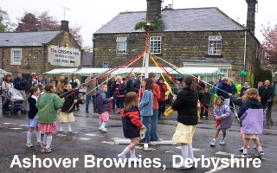
On May Day, people used to cut down young trees and stick them in the ground in the village to mark the arrival of summer.
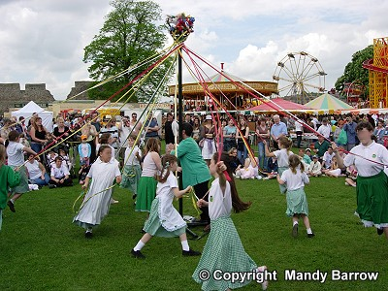
People danced around the tree poles in celebration of the end of winter and the start of the fine weather that would allow planting to begin.

Maypoles were once common all over England and were kept from one year to the next.
Schools would practice skipping round the pole for weeks before the final show on the village greens.
The end results would be either a beautiful plaited pattern of ribbons round the pole or a tangled cat's cradle, depending on how much rehearsing had been done.

Maypoles are still a part of some village life and on May Day the villagers dance around it.

Try this Maypole Song (tune : « here we go round the Mulberry bush »)

Maypole Song
Here we go around the pole,
Round the pole,
Round the pole,
Here we go around the pole
On the first day of May.
(Students' name) goes around the pole,
Round the pole,
Round the pole,
(Students' name) goes around the pole
On the first day of May.
-----------------------------------------------------------------------------------------------------------------

May Baskets
Another popular May Day custom is to create a May Day basket. These baskets are filled with candies and flowers and left on the doorstep of a friend's home.

Create your own basket and give it to somebody you miss or you love

DLTK's Crafts for Kids
May Day Basket Paper Plate Handprint Craft
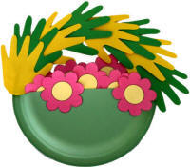with handprints

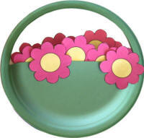 Without handprints

Materials:
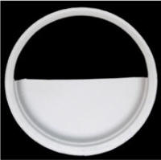
- printer,
- glue,
- scissors,
- something to colour with,
- paper plate
- paint and paintbrush

- Instructions:
- Print out two or three copies of the flower templates.
- Colour the pieces and cut them out.
- Cut out the top half of the paper plate, leaving the rim intact.
- Note: Our handprints were age 4... If you have larger hands, you might want to cut off the rim and add a bigger cardboard handle that makes the basket an oval so you have a bit more room to work with.
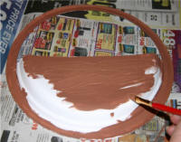
- Paint the bottom of the paper plate including the rim.
- Trace the plate onto a piece of construction paper or cardboard (old cereal boxes work well).
- Cut out the piece.
- Glue or tape the piece onto the back of the painted plate. This will create a narrow 'pocket' or basket.
- Glue flowers into the basket. Some against the back of the basket and some inside the front. You can even add a couple hanging over the edge.
- You can slip little candies or messages inside the basket.
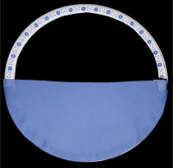
- Trace handprints onto construction paper in whatever colour you prefer.
- Glue or tape the handprints along the rim of the basket as a handprint handle.

Craft Templates

